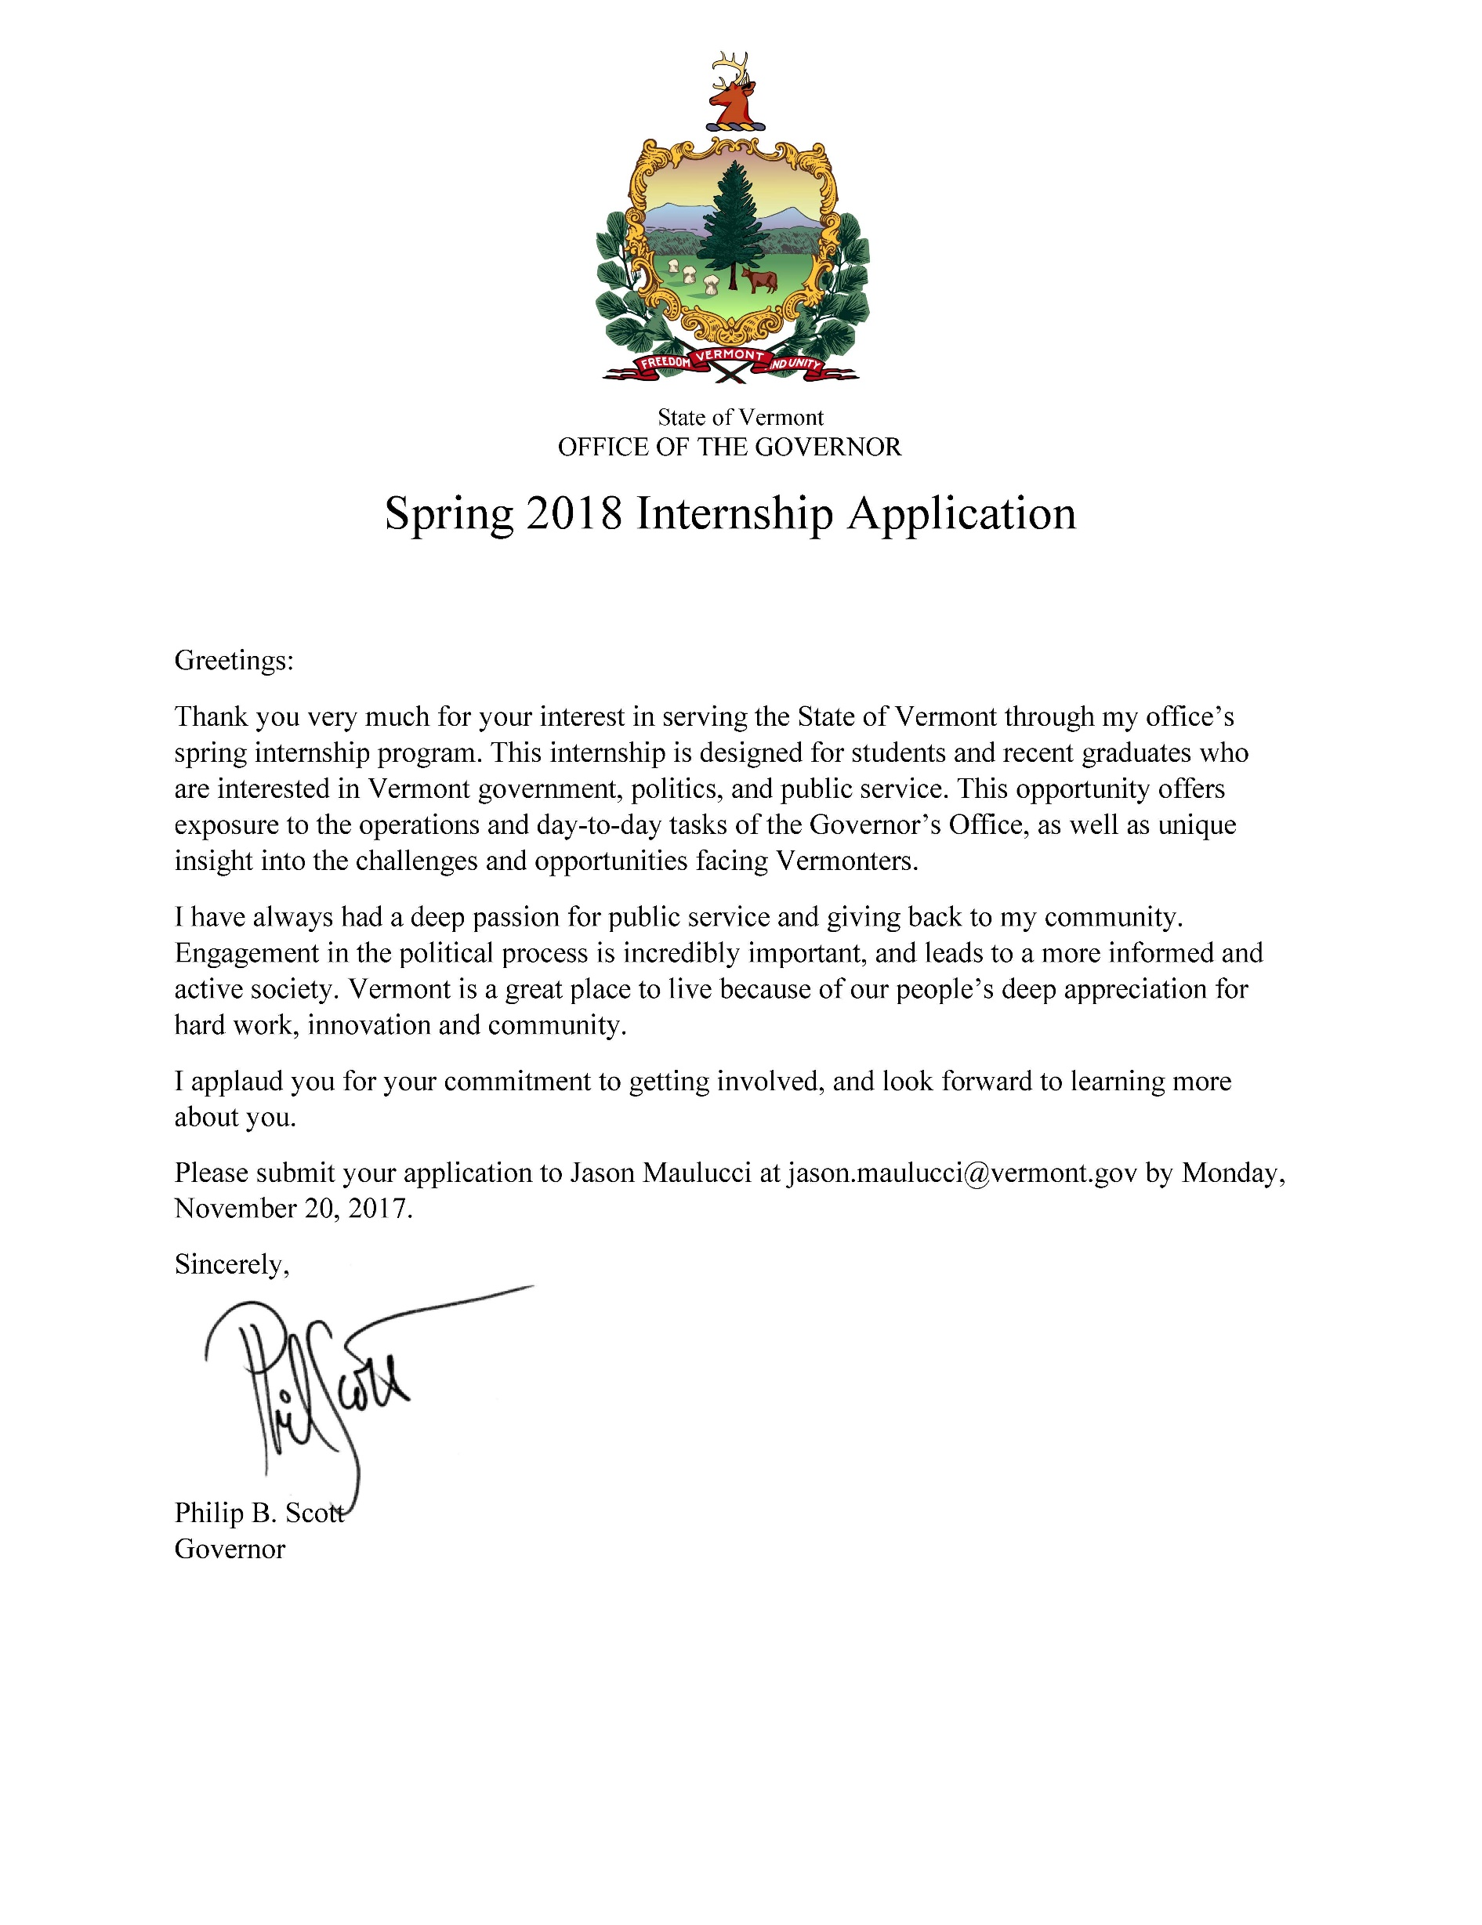
PERSONAL INFORMATION
Please fill out the following information.

GENERAL INFORMATION

Full Name:
Email:
Phone Number:
Address:
How many/which days per week will you be available this semester?

What would your start/end dates be?

EDUCATION
Most Recent School Attended:
Date of Graduation/Expected Date:
Major (if applicable):
Minor (if applicable):

REFERENCES
Please provide us with at least two references (not related to you) who can speak on your behalf.

Reference 1*
Name:
Relation to you:
Email:
Phone Number:
Reference 2*
Name:
Relation to you:
Email:
Phone Number:
Reference 3
Name:
Relation to you:
Email:
Phone Number:
QUESTIONS
Please answer the following questions within the given word-count parameters.

Discuss an issue that the Governor and/or Legislature are dealing with that matters to you, and why it matters to Vermont (400 words or less).

How do you stay informed (examples: specific news sources, social media, conversations, etc.)? Explain the importance of a well-informed populous (300 words or less).

Describe a time during which you had to overcome obstacles in order to achieve a goal (300 words of less).

What other information would you like the Governor to know about you (400 words or less)?

Please submit this application, as well as a resume, to Jason Maulucci at Jason.Maulucci@Vermont.gov by November 20, 2017.

